Problem 3, 2.11
(a)
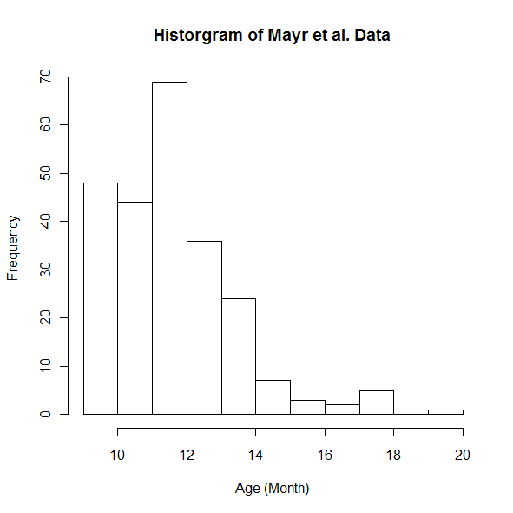
By looking at this histogram, I do not think the sampling distribtion of the sample average will be normally distributed because there is an obvious skewing to the right on the plot. However, since the sample size is greater than 30, we can assume normality in this case according to the Central Limit Theorem.

(b)
Mean = y̅ = 12.07917
Sample Variance = s² = 3.705003

V̂(y̅) = 0.01543751
SE(y̅) = 0.1242478

The 95% Confidence Interval for the average age for onset of free walking is:
(11.83564, 12.32269)

(c) The sample size needed for this research is approximately 57 since n = 56.93257.

Problem 2:
- All the possible values of the sampel total T are:
33 37 39 41 43 45 47 49 51 56 57 58 60 61 62 63 64 65 66 67 68
69 70 79 80 81 82 83 84 85 86 87 88 89 102 103 104 105 106 107 108

- This distrbituion table of the sample total T is:
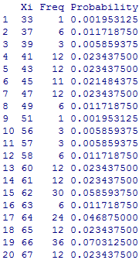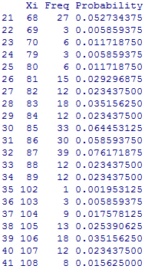

- The distribution table of the sample total T without replacement is:
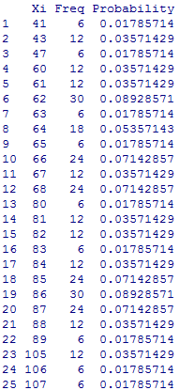

- With Replacement:
Mean = 74.625
Var = 331.726

Without Replacement:
Mean = 74.625
Var = 237.1903
Problem 4: 2.16
- The histogram is:
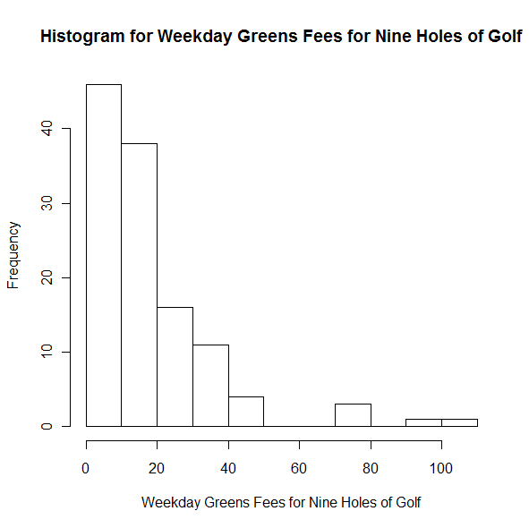
This shape of this histogram is skewed to the right, and it does not imply normality in this case.

- Mean = y̅ = 20.15333
s² = 321.3570
SE(y̅) = 1.629866

